**Types of Machine Learning**

1. Supervised
2. Unsupervised
3. Semi-Supervised
4. Reinforcement
5. Supervised Learning
6. Regression
7. Classification

* Supervised Learning:

When you have data of inputs and output corresponding to those inputs then it comes under the supervised learning.

For example:

Classification: We have data about students [IQ,CGPA,Got Job]

Features, Label

| 90,3.9,Yes|

| 80,3.5,Yes|

| 70,2.9,No|

Regression: We have data about students [IQ,CGPA,Salary]

Features, Label

| 90,3.9,20k|

| 80,3.5,20k|

| 70,2.9,10k|

Supervised Learning have two types Regression and Classification. To distinguish between two of them we have to know the data type.

If the data is continuous form means in numerical form and target value (label) is in numerical form then it is regression problem. If your data is in categorical form and target value (label) is in categorical form then it is classification problem.

1. Unsupervised Learning:
2. Clustering
3. Dimensionality Reduction
4. Anomaly Detection
5. Association Rule Learning

* Unsupervised Learning:

When we have data containing only inputs (Features) but we don’t have any output (Label) column then this type of learning will be called unsupervised learning. It has four types as mention above.

For example:

[IQ,CGPA]

Features

| 90,3.9|

| 80,3.5|

| 70,2.9|

**Clustering**: can detect the data and assign them to a certain group on the bases of features (inputs). With the help of unsupervised learning we can create labels against the features. As you can see in the fig below.

**Dimensionality Reduction:** When you have large number of columns in your dataset then this algo will reduce the number of columns. It will merge the same nature of columns into a single column. For example, if we have house price prediction problem and we have lot of columns in it. Let say noofrooms, nofowashroom they are same in nature. These cols are extending the area of house so dimensionality reduction algo will merge them into a single col let say areasquarefeet. This process is called feature extraction. With this you will be able to visual the data easily.

**Anomaly Detection**: In data analysis, anomaly detection is generally understood to be the identification of rare items, events or observations which deviate significantly from the majority of the data and do not conform to a well defined notion of normal behaviour.

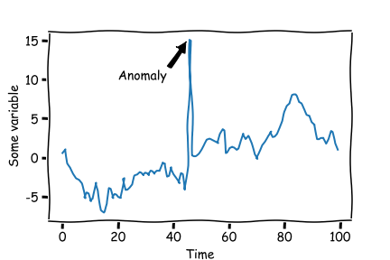

**Association rule learning** is a rule-based machine learning method for discovering interesting relations between variables in large databases. It is intended to identify strong rules discovered in databases using some measures of interestingness.

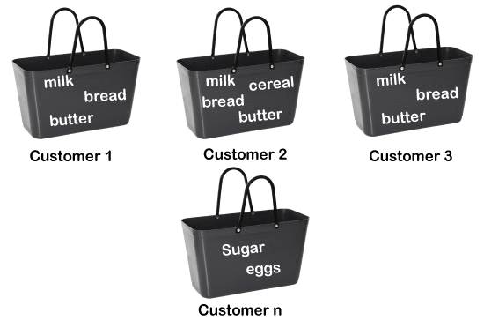

1. **Semi-Supervised**: **Semi-supervised learning** bridges supervised learning and unsupervised learning techniques to solve their key challenges. With it, you train an initial model on a few labeled samples and then iteratively apply it to the greater number of unlabeled data.

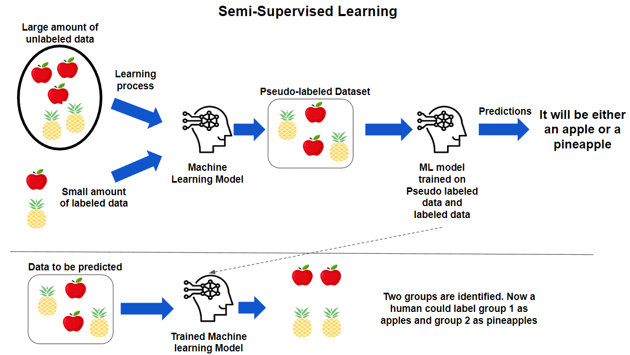

1. **Reinforcement Learning:** **Reinforcement Learning** is defined as a Machine Learning method that is concerned with how software agents should take actions in an environment. Reinforcement Learning is a part of the deep learning method that helps you to maximize some portion of the cumulative reward.

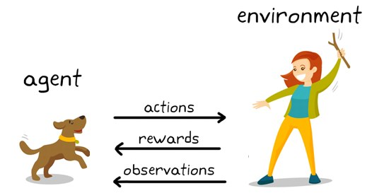

**Always to Remember This Diagram**

